***Amendment to Invoice Item and Invoice Module***

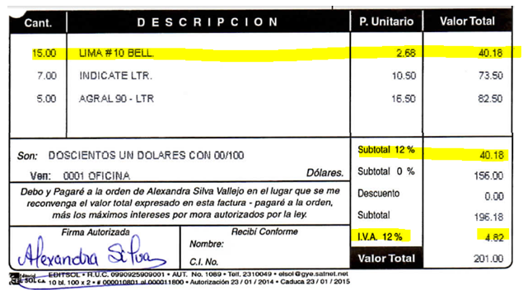

***Suggestion***

1. Additional table to be introduced to let user select applicable rate

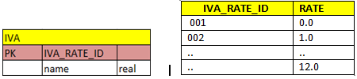

1. Add **IVA_RATE, IVA_ID** fields to the **Invoice Items** table.

|  |  |  |  |
| --- | --- | --- | --- |
| **Invoice Items** | | | |
| PK | Invoice Item |  |  |
|  | Purchase Invoice ID | FK |  |
|  | Material Id | FK |  |
|  | Quantity |  | text |
|  | Subtotal |  | real |
|  | Shipping |  | real |
|  | Packaging |  | real |
|  | Unit Cost |  | real |
|  | IVA_RATE (**new**) |  | real |
|  | IVA_ID (**new**) |  | Small.int |
|  | Discount |  | real |
|  | Tax(calculated field) |  | real |
|  | Total |  | real |

The user selected the IVA rate (Invoice Items) and the system calculated IVA value and saves both values.

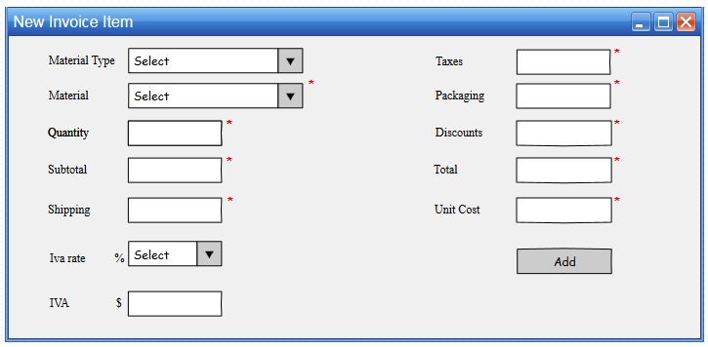

This is to avoid that the system re-calculate the IVA when the user edit a purchase inovoice or when the user wants to list the items of the invoice

